**EXPERIMENT -4**

Experiment 4a- MAXIMUM, MINIMUM AND AVERAGE OF N NUMBERS

Step 1: Start

Step 2: use variables high , low , and sum

Step 3: Read the count of numbers as n

Step 4: Set high = a , low = a , sum = a and i= 1

Step 5: Repeat steps 6 to 10 while i=n

Step 6: Read the number as c

Step 7: Set Sum = sum + c

Step 8: If c>high set High = c

Step 9: If low>c then set low = c

Step 10: set i=i+1

Step 11: Avg = sum/n

Step 12: Put the highest number , the lowest number and avg of numbers

Step 13: End

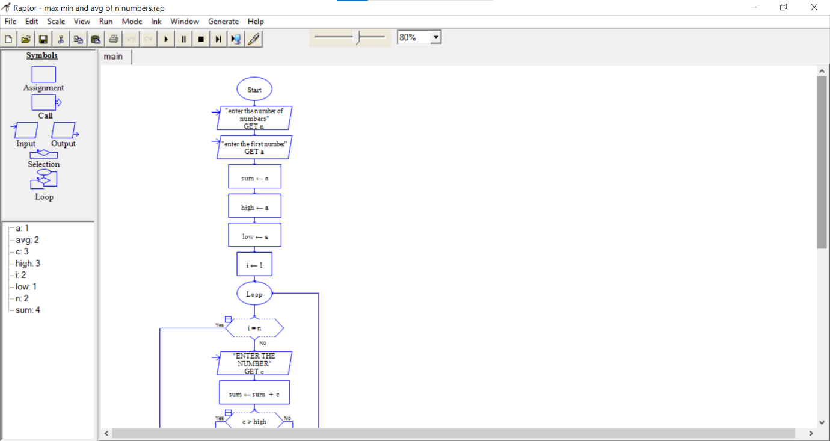

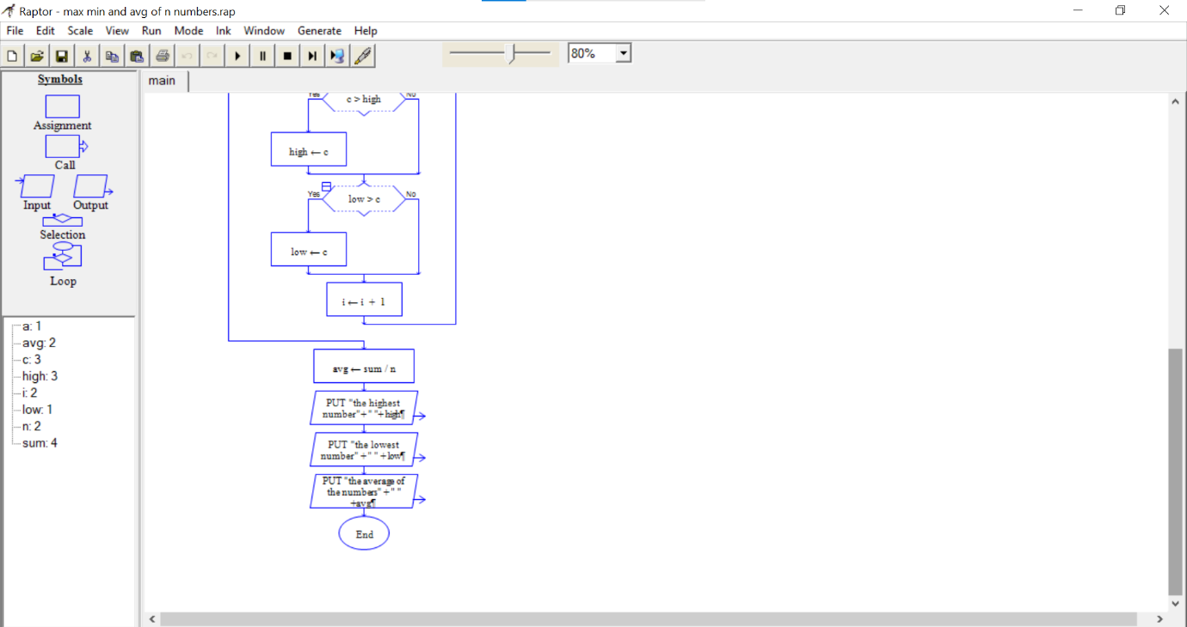

Experiment 4b - CONVERSIONS

Step 1:Start

Step 2:use call for time ,distance ,area ,volume and temperature

Step 3: in time input a number and its unit (seconds or hours)(a,b)

Step 4:use if (b= seconds)

Step 5: if yes ,x=(a/60)/60,print (x+”hours”)

Step 6: else x=a*60*60,print (x+”seconds”)

Step 7: in distance input a number and its unit (metre or centimetre)(a,b)

Step 8:use if (b= centimetre )

Step 9: if yes ,x=(a/10)/10,print (x+”metre”)

Step 10: else x=a*10*10,print (x+” centimetres”)

Step 11: in area input a number and its unit (metre square or centimetre square)(a,b)

Step 12:use if (b=centimetre square)

Step 13: if yes ,x=(a/100)/100,print (x+”metre square”)

Step 14: else x=a*100*100,print (x+” centimetres square”)

Step 15: in volume input a number and its unit (metre cube or centimetre cube)(a,b)

Step 16: use if (b=centimetre cube)

Step 17: if yes , x=(a/1000)/1000,print (x+”metre cube”)

Step 18: else x=a*1000*1000,print (x+” centimetres cube”)

Step 19: in temperature input a number and its unit (Celsius or Fahrenheit)(a,b)

Step 20: use if (b=Celsius )

Step 21: if yes ,x= ((a-32)*5)/9,print (x+”Fahrenheit”)

Step 22: else x= ((a*9)/5)+32,print (x+”Celsius ”)

